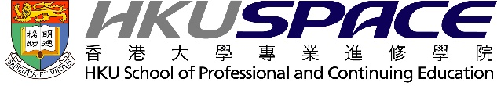
Certificate for Module (Paediatric Oncology for Healthcare Professionals)
證書（單元：醫護專業人員兒科腫瘤學）

This QF Level 6 part-time programme is designed to empower healthcare professionals to deliver comprehensive and compassionate care to paediatric cancer patients. Participants will gain specialised knowledge in paediatric cancer diagnosis, treatment, and holistic patient care, delivered through an evidence-based and multidisciplinary approach.
Programme Highlights
• Start Date: 29 May 2026 (Friday)
• Duration: 48 hours
• Study Mode: Part-time
• Language: English
• Course Fee: HK$9,800
• Credit: 15
• QF Level: 6
•Course Code: HS240A
• Application Code: 2385-HS240A
Intended Learning Outcomes
Upon completion of the programme, participants will be able to:
- Critically review clinical challenges in paediatric oncology
- Appraise recent advances in treatment techniques
- Construct holistic, multidisciplinary care plans
- Implement evidence-based strategies to address complex health needs
Syllabus Includes
• Overview of Paediatric Oncology
• Laboratory Tests and Imaging for Childhood Cancers
• Common Paediatric Oncology Diseases (I & II)
• Radiation Therapy, Targeted Therapy, Chemotherapy, and HCT
• Management of Anaemia, Bone Marrow Failure, and Infections
• Pharmacological and Surgical Care Management
• Palliative and Psychosocial Support
• Communication and Counselling Skills
• Multidisciplinary Team Collaboration
• Nutritional Support for Paediatric Cancers
This programme is particularly suitable for professionals in paediatrics, oncology, nursing, and allied health disciplines. We also encourage department heads and clinical supervisors to consider nominating staff members who would benefit from this specialised training.

Enrolment is now open.
For enquiries, please contact Ms Rosa Chan at ymr.chan@hkuspace.hku.hk or call 2975 5687.
Programme Details/Enrolment:
https://hkuspace.hku.hk/prog/cert-for-module-paediatric-oncology-for-healthcare-profs#programme-overview

